# Changing Languages on the Page:

Step 1.

GO to <https://support.bastiansolutions.com> and SIGN IN with your credentials.

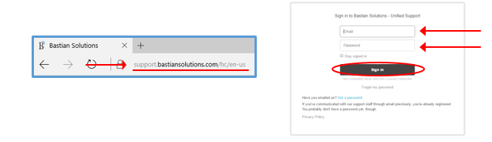This will take you to your user home page.

Step 2.

CLICK on the language dropdown box in the top left corner under Bastian Solutions logo. 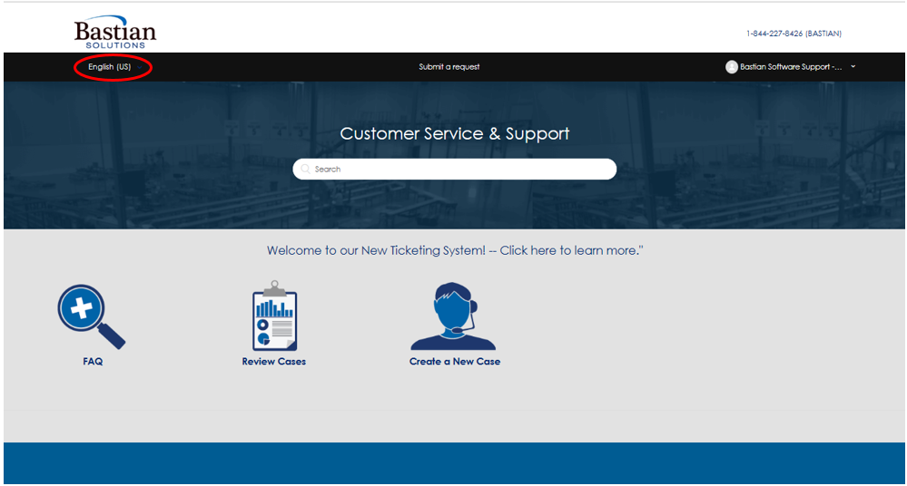

Step 3.

Select the language you would like to view the site in.

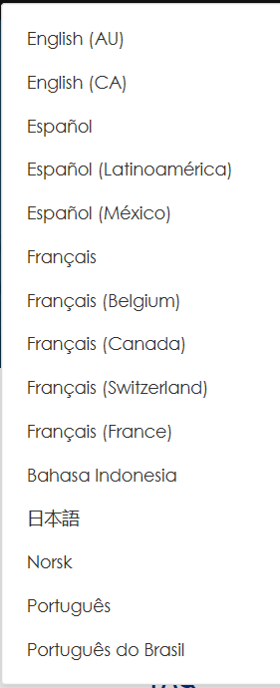

The forms on the site will change to the selected language.

