Submitting Tickets:

Step 1.
GO to https://bastianunifiedsupport.zendesk.com and SIGN IN with your credentials.
This will take you to your user home page.
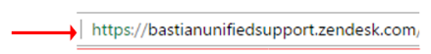
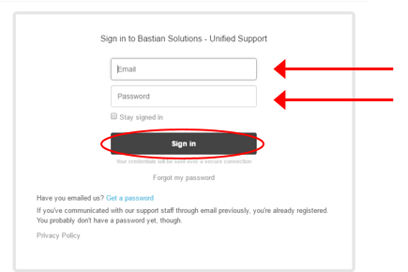

Step 2.
CLICK “Submit a request” at the top of the screen or CLICK “Create a New Case”.
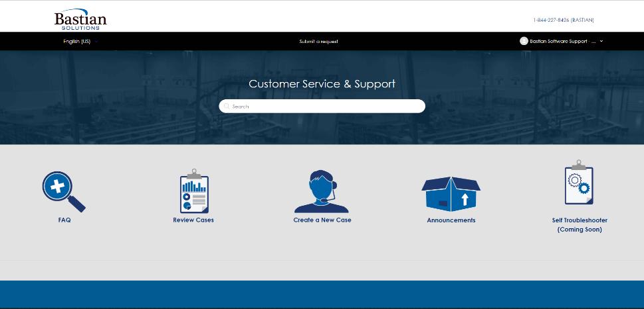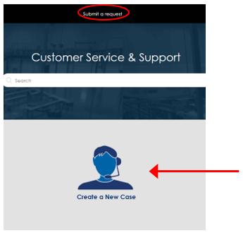

Step 3.
FILL IN the SUBJECT line. The subject line should give an idea of the issue.
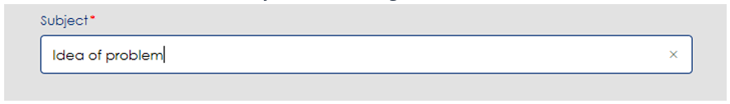

Step 4.
FILL IN the DESCRIPTION text box. The description should explain the problem that has occurred in detail.
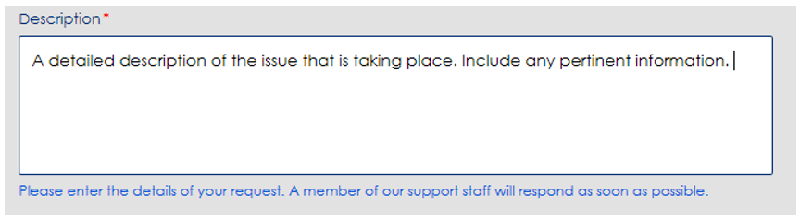

Step 5.
(Optional) FILL IN the ERROR MESSAGE text box. If the problem you have encountered presents you with an error code, copy and paste it in then text box.
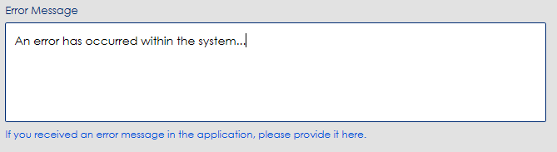

Step 6.
(Optional) FILL IN the APPLICATION NAME text box. If there is a specific application that is associated with the issue, insert the name of that application into the Application text box.
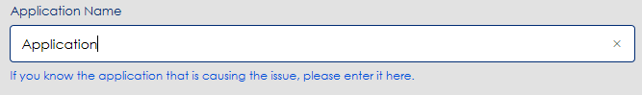

Step7.
(Optional) ADD an ATTACHMENT. If you have taken any screenshots that or have any other documentation that could be useful for correcting the issue, attach them to the ticket.
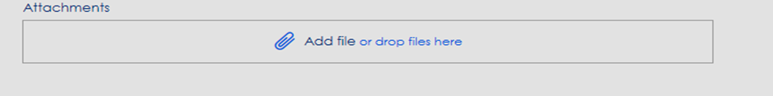

CLICK “Add file” and navigate to the correct file or DRAG and DROP the file within the space provided.
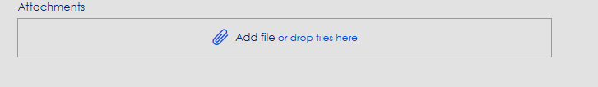

Step 8.
CLICK “Submit”
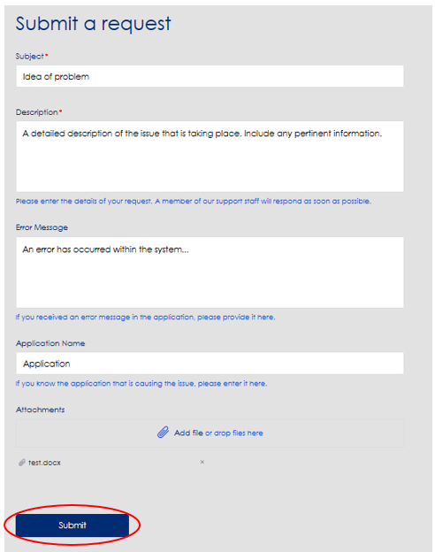

Once your ticket has been submitted, you will be able to see updates as well as having an open line of communication with Support about the issue.
