Logging into the Zendesk Portal:

Step 1.
Go to https://bastianunifiedsupport.zendesk.com
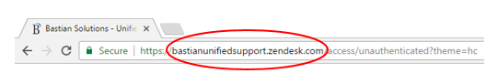
Step 2.
This brings you to the log in page.
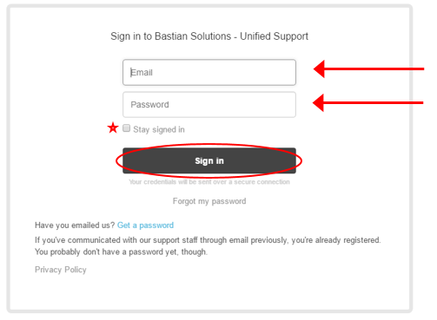

Fill in your email address and password. If you would like to stay signed in to this page with your user name and password, check the “Stay signed in” check box. Once completed, click the “Sign in” button This will bring you to the to your user portal.
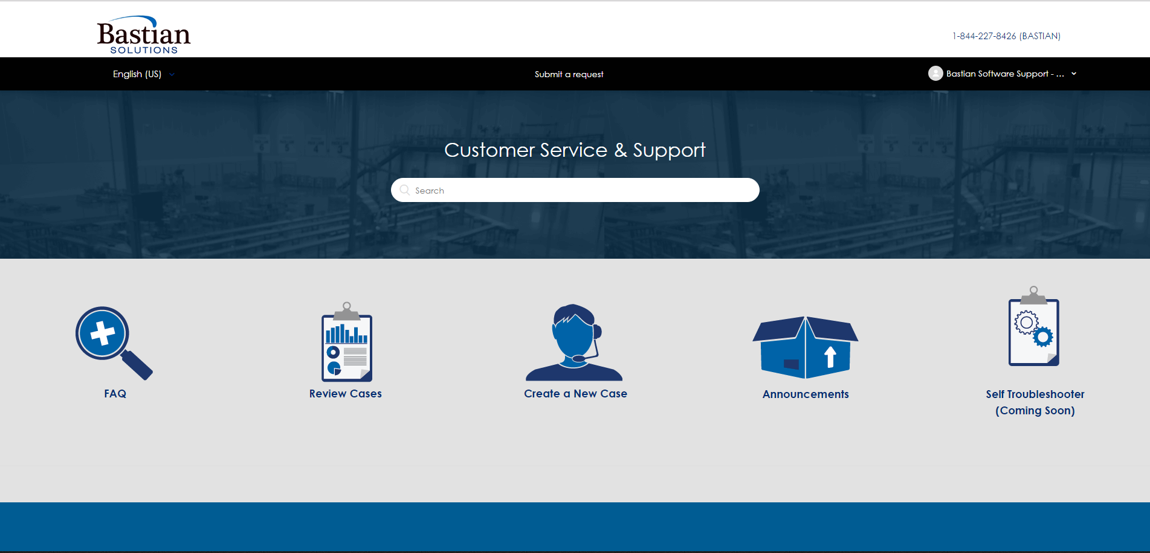

Welcome to the new Bastian Software Solutions’ ticketing site!

